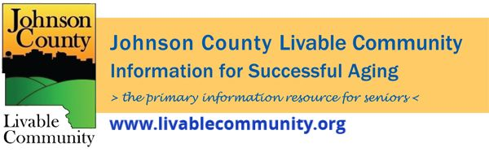

November 2021 Newsletter
In this month's issue:
- Holiday Coping Strategies
- Johnson County Public Health
- Free Thanksgiving Meals
- Project Holiday
- Mobile Crisis Outreach
- Iowa Rent and Utility Assistance
- Great American Smokeout
- Mental Health Resources
- Medicare Open Enrollment
- Senior Issues Forum
- Snow Removal Sign-Up
- Energy and Water Assistance
- Virtual Programming


Holiday Coping Strategies Virtual Discussion
November 16th, 2021 at 1PM
This has been another tough year for many individuals as we continue to endure through the pandemic and search for a return to some level of pre-pandemic normalcy in our lives. In this session, we will discuss the sense of loss that is facing many of us during this holiday season. The loss can be the result of death, physical distance or social distance.
Mercedes Bern-Klug will facilitate a discussion about how to recognize the sense of loss in ourselves and in others, and consider ways to respond to the loss during the holiday season.
This virtual event is free to attend. You must register in advance at the following link: https://us02web.zoom.us/webinar/register/WN_yNqz5o_gTg6Nin-ch_OUkg
Mercedes Bern-Klug is the Director of the School of Social Work. Her research is in long-term care and advance chronic illness and includes working with family members who share medical decision-making responsibilities with nursing home residents. She is a former Alzheimer support group leader and an Honoring Your Wishes facilitator.
This event is presented by the Johnson County Livable Community Caregiver Action Team.

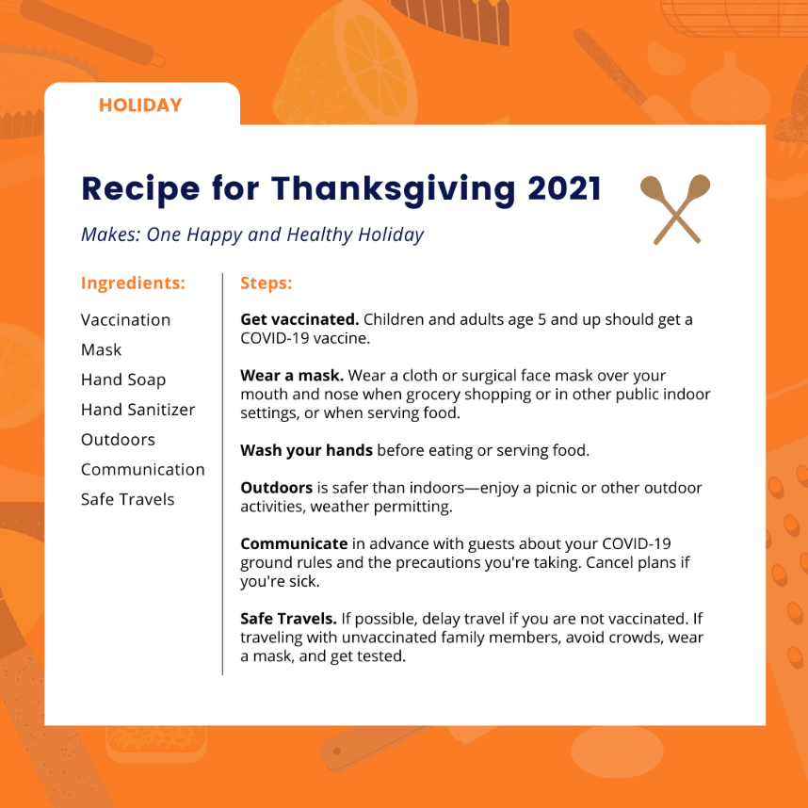
Johnson County Public Health
We wish everyone a safe get together with friends and family for your holiday get together this year.

Free Thanksgiving Meals
St. Mary's Annual Thanksgiving Dinner- Thursday, November 25th
St, Mary's in Iowa City will be providing to-go style Thanksgiving dinner. Meals include turkey, dressing, mashed potatoes and gravy, green bean casserole, dinner roll, cranberry sauce and pumpkin pie.
You may either pick-up your meal curbside between noon and 1PM or have it delivered to your home. Please RSVP by noon on Monday, November 22nd and let them know which option you prefer and how many you will need by emailing icstmary@icstmary.org or by calling 319-337-4314.
North Liberty Community Thanksgiving Dinner- Thursday, November 25th
A full Thanksgiving meal available for residents of North Liberty at the South Slope Community Center, 980 North Front Street in North Liberty from 12-4PM. The meal will be served at SouthSlope and will not be a to-go meal. Masks are required when not seated at your table.
For general information about the Thanksgiving dinner, please contact Amanda at amanda@southslope.net or 319-530-0135.
Solon Free Thanksgiving Meal- Friday, November 26th
The Senior Advocates and Solon Senior Support are serving a traditional dine-in Thanksgiving meal for seniors at the Methodist Church Fellowship Hall at 12 noon Friday, November 26, catered by Sam's Main Street Market. Call 319-430-8655 or 319-270-9884 for reservations by November 19.
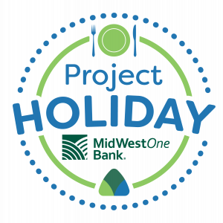
Project Holiday
Johnson County residents can register to receive a Project Holiday Meal through CommUnity. Clients who register by November 30th will have their first choice of entree, but there will be meals available for clients who arrive without signing up.
Click here for more information and to see the entree choices, pickup and delivery information and more.
Register by phone at (319) 351-0128
Register online using this form
Register in person at Pepperwood Plaza Food Pantry during regular business hours.

Mobile Crisis Outreach
With Mobile Crisis Outreach, mental health counselors are dispatched to homes, schools, businesses, or public spaces where a mental health crisis is occurring. Response time is within 60 minutes of dispatch. Anyone who is experiencing or is concerned about someone experiencing a mental health crisis can call.
Please call Mobile Crisis Outreach if you or the person in crisis:
- is willing to meet with Mobile Crisis Outreach
- is having suicidal ideations
- is unsure whether psychiatric hospitalization is necessary
- needs crisis de-escalation, emotional support or referral to community resources
Mobile Crisis Outreach is not appropriate:
- when the situation needs immediate response such as a medical emergency or a current threat of violence
- when the person in crisis does not agree to talk with mobile crisis counselors
To learn more about CommUnity Crisis Services & Food Bank, visit builtbycommunity.org.
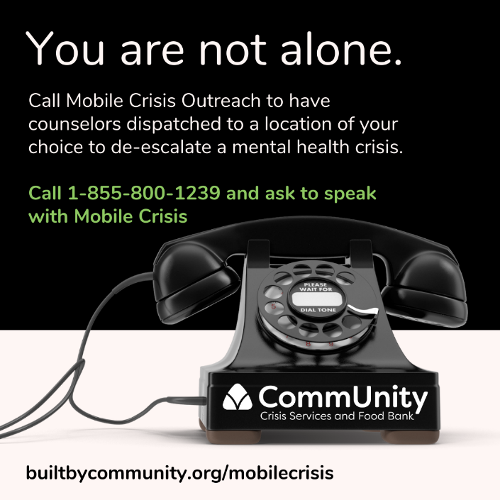
Iowa Rent and Utility Assistance Program
The Federal Emergency Rental Assistance Program administered through the Iowa Finance Authority is still accepting applications. This program may provide eligible individuals with assistance for a period of up to 12 months with past sue rental assistance incurred no earlier than March 13, 2020 and up to 3 months of future rental assistance at a time. The program may also provide for utility payment asssitance for eligible individuals for electricity, gas, propane or fuel oil, water, sewer and/ or trash removal.

Eligible Households
- Renter households with incomes of no more than 80% of Area Median Income.
- One or more individuals in the household has qualified for unemployment benefits.
OR has experienced a reduction in household income, incurred significant costs or experienced other financial hardship due directly or indirectly to the coronavirus outbreak.
- The household can demonstrate a risk of experiencing homelessness or housing instability which may include a past due utility or rent notice or eviction notice.
More information about the program can be found at: https://www.iowafinance.com/iowa-rent-and-utility-assistance-program/
Have questions about the Rent and Utility Program or your application? Contact the Housing Recovery Support Team at 515-348-8813 or -855-300-5885.

Great American Smokeout
Join Johnson County Public Health in supporting people who are working hard to quit using tobacco/vape products by participating in the American Cancer Society Great American Smokeout® on Thursday, November 18, 2021. This is wonderful opportunity to encourage your employees and customers to live healthy, tobacco-free lives.
About 34 million American adults still smoke cigarettes, and smoking remains the single largest preventable cause of death and illness in the world. Smoking causes an estimated 480,000 deaths every year, or about 1 in 5 deaths.
- While tobacco use among youth has greatly decreased over the past 25 years, ANY youth tobacco use is concerning. Unfortunately, we know vaping has become popular among teens and young adults.
  - In Iowa –
    - 22.4% of 11th grade students use e-cigarettes. (9.1% in 2016; 10.9% in 2014)
    - 5.6% of 11th grade students use cigarettes. (7.1% in 2016; 10.0% in 2014)
  - University of Iowa –
    - UI Undergraduates Spring 2021 - use of tobacco/nicotine in lifetime 37.7%; use in last 3 months 25.6%
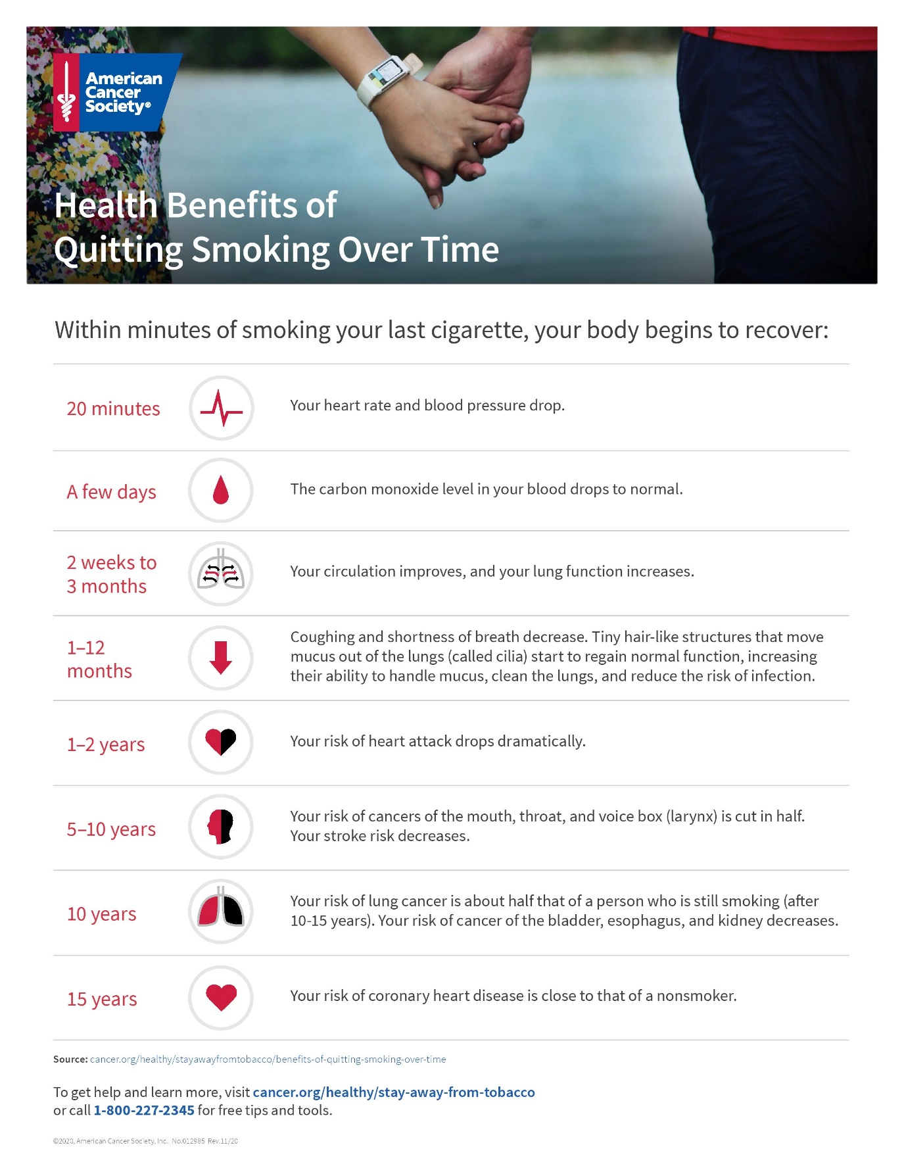
Source: https://www.cancer.org/healthy/stay-away-from-tobacco/benefits-of-quitting-smoking-over-time.html

Mental Health Resources
Iowa Warm Line
The Iowa Warm Line is a peer-run, telephone based, non-crisis and confidential listening line for anyone struggling with mental health or substance abuse issues. The Warm Line is staffed by individuals who have been through a similar journey and are in recovery themselves. The phone number to call is 1-844-775-9276. Calls are answered seven days a week from 5-10PM.
Disaster Distress Helpline: 1-800-985-5990
The Disaster Distress Helpline is a 24/7, 365-day-a-year, national hotline dedicated to providing immediate crisis counseling for people who are experiencing emotional distress related to any natural or human caused disaster.
CommUnity Crisis Call/ Chat/ Text: 1-855-325-4296
Call, chat or text to be connected to a trained crisis counselor. They will listen, help you explore your feelings, work with you to create a safety plan if you think it would be helpful, and connect you to resources as needed.
Phone: Call 1-855-325-4296 and you'll be connected to a trained crisis counselor in Iowa City, IA.
Chat: Go to IowaCrisisChat.org and click "Chat Now." You will fill out a survey that helps them learn more about how you're feeling. You will be connected with a trained crisis counselor in a private chat.
Text: Text 1-855-325-4296 from 9am-2am Central.
Local Mental Health Organizations
- CommUnity, formerly The Crisis Center
  - CommUnity provides services such as Mobile Crisis Outreach and the Crisis Phone/ Chat/ Text listed above.
- NAMI Johnson County
  - NAMI Johnson County is the local affiliate of NAMI Iowa and NAMI National. NAMI, the acronym for the National Alliance on Mental Illness, is the nation’s leading grassroots, self help, education, support and advocacy organization dedicated to improving the lives of individuals and families affected by mental illness.
- AbbeHealth Services
  - AbbeHealth Services is a regional nonprofit organization dedicated to providing mental health and aging services that help individuals achieve their optimum levels of independence and success.
- Prelude Behavioral Services
  - Prelude Behavioral Services offers prevention services, substance abuse and addiction treatment, drug testing, family services, and more.
Online Support Groups
- Suicide loss online support group
- Hearing Voices online support group

Medicare Open Enrollment Ends December 7th
Make sure you review your Medicare plan as open enrollment is going on now through December 7th. Need assistance, contact one of the local SHIIP offices at either the Iowa City Senior Center (319-356-5220) or Mercy Hospital (319-339-3658). You can also schedule appointments online through the Senior Center by clicking here.
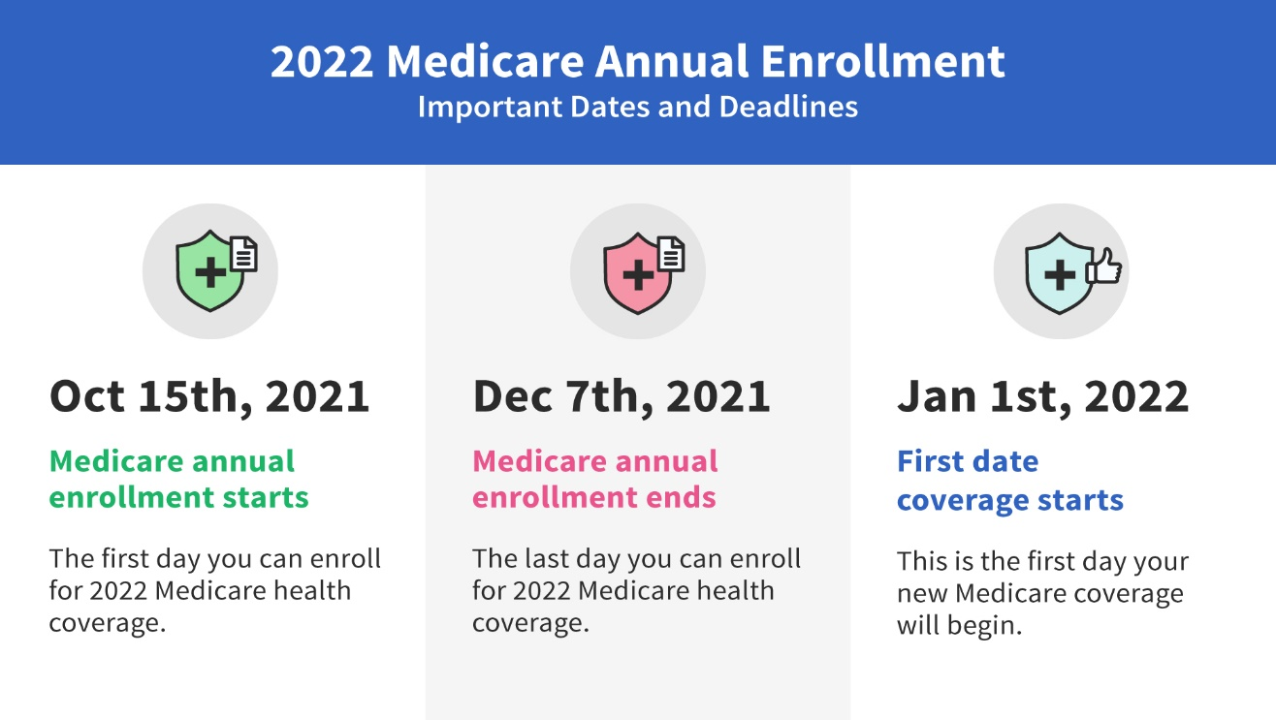
Snow Removal Program
Aging Services is expanding its snow removal program in Johnson County by adding additional openings in Iowa City, Coralville and North Liberty. This service, which is very basic, is ideal for those who have physical disabilities, severe arthritis, neuropathy, heart conditions or other risk and cannot afford regular snow removal. For more information, please contact Aging Services at 319-398-3644. Openings are limited.


Energy and Water Assistance
The Low-Income Home Energy Assistance Program (LIHEAP) and Low-Income Household Water Assistance (LIHWAP) is designed to help low-income individuals and families meet the cost of home heating and water. Applications are currently being accepted for persons over the age of 60 and/ or disabled. Applications are open for everyone else on November 1st and will be accepted through April 30, 2021.
For more information or to apply online visit: https://www.hacap.org/energy
Printable applications can be downloaded here.



Local Programming & News
AARP Iowa- Upcoming Events
Hancher Auditorium- Upcoming Events
Iowa City Senior Center- November/ December Programs and Updates
North Liberty Senior 55+ Connections Lunch- In-person lunches and programming- Click here for the calendar. Call (319) 626-5701 or email agolly@northlibertyiowa.org
Stanley Museum of Art- Click here for their website.
Solon Senior News- Click here for their November Newsletter
TRAIL of Johnson County- Their calendar features a curated collection of virtual public events (as well as those just for TRAIL members) that they select from local, regional, and national sources. That link is here: https://trailofjohnsoncounty.org/calendar

*THE JOHNSON COUNTY LIVABLE COMMUNITY NEWSLETTER IS A DIGITAL NEWSLETTER- THIS HAS BEEN CONVERTED TO A PRINTABLE FORMAT FOR ALL TO READ. PLEASE NOTE THAT MANY OF THE CLICKABLE LINKS WILL ONLY WORK WHEN VIEWED THROUGH A DIGITAL DEVICE.
TO SUBSCRIBE TO THE MONTHLY JOHNSON COUNTY LIVABLE COMMUNITY NEWSLETTER YOU MAY VISIT https://livablecommunity.us3.list-manage.com/subscribe?u=a9f307a3cbce1cc4ca622bb7f&id=d21460a2e3 or contact Jeff Kellbach at jkellbach@johnsoncountyiowa.gov

