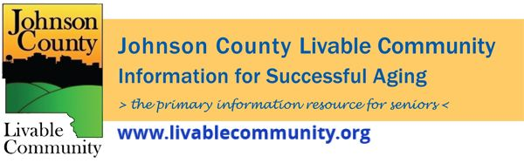

March 2022 Newsletter
In this month's issue:
- SNAP Benefits Update
- Free Tax Preparation Services
- Learn- N- Earn Workshops
- Planning for Peace of Mind Event- Powers of Attorney and Living Wills
- Daylight Savings Time
- March For Meals
- JCLC Policy Board Vacancies
- Elder Services is now Meals on Wheels of Johnson County
- Powerful Tools for Caregivers
- Iowa City Public Library March Events
- Clean Air For Everyone
- Local Programming and News
SNAP Benefits
During the COVID-19 pandemic, Department of Human Services has been giving all eligible households the maximum SNAP benefit amounts. Starting on April 1, DHS will stop giving maximum benefits and begin determining benefit amount based on household size and income again. Some people are going to see significant drops in monthly benefits. It is important for households to make a plan to account for these differences, ahead of time.
Below is a list of some of the resources available in our communities, for a full resource list check out the Food Assistance Guide:
CommUnity Food Pantry at Pepperwood
1045 Highway 6 East in Iowa City, 52240
Hours:
Monday: 12PM-4:30PM
Tuesday: 12PM-7PM
Wednesday: 12PM-4:30PM
Thursday: 9:30AM-4:30PM
Friday: 12PM-4:30PM
Saturday: 9:30AM-2PM
Coralville Food Pantry
1002 5th Street Coralville, IA 52241
Hours:
Tuesday: 2PM-6PM
Wednesday: 10AM-12PM
Thursday: 10AM-12PM
Friday: 10AM-12PM
Saturday: 10AM-12PM
North Liberty Community Pantry
89 North Jones Boulevard, North Liberty, IA 52317
Hours:
Monday: 10AM-12PM
Tuesday: 10AM-12PM and 3PM-6PM
Wednesday: 10AM-12PM
Thursday: 10AM-12PM and 3PM-6PM
Saturday: 10AM-12PM
Solon Community Food Pantry
122 N. West St., Solon, IA 52333
Hours:
Monday: 2PM-6PM
Free Tax Preparation Services
It’s tax season again! We know filing taxes can be long, and confusing which is why we have some resources that can help – for FREE. Here are the details for two different services.
AARP Foundation Tax Aide
Free tax preparation services will be offered by appointment at the Senior Center in February-April 2022. Low to moderate income taxpayers, especially those age 60+, can receive this free service, provided by trained volunteers through a partnership with the AARP Foundation Tax-Aide Program. Click here to schedule an intake appointment.
For health and safety, this year's tax appointments will be provided with minimal contact:
- Clients will schedule an intake appointment to drop off and inventory their tax-related materials and sign a couple forms.
- A counselor will prepare the tax return while the client waits; the counselor will consult the client with any questions.
- The counselor will review the completed return with the client before e-filing; clients should expect the process to take approximately 60-90 minutes.
To have taxes prepared, clients must bring:
- Copies of the last two years of federal and state tax returns filed
- Photo ID and Social Security card for each taxpayer included on the return
- Bank routing/account number for direct deposit/debit
- W-2 forms, 1099 forms, other statements of income
- If applicable, additional documentation detailing itemized deductions and credits/adjustments
- 1095-A forms if you purchased insurance through the Marketplace (Exchange)
- For more details on important documents, visit https://www.aarp.org/money/taxes/info-01-2011/important-tax-documents.html
VITA Tax Clinic:
The IRS Volunteer Income Tax Assistance (VITA) Program is offering free tax help to people who need assistance in preparing their tax return. Help is available to the following individuals:
- People who generally make $57,000 OR LESS
- Persons with disabilities
- Limited English speaking taxpayers
Due to COVID, VITA will be using mostly contact-less delivery options.
To get started email, Vita@uiowa.edu, call 319-335-0857 or click here.
After completing the form in this link, the VITA intake forms will be sent to you.
Horizons Financial Wellness Center Learn-N-Earn Workshops
The Financial Wellness Center Learn-N-Earn Workshops cover Credit, Savings and Debt Management. This interactive presentation allows attendees to identify financial goals, discuss strategies to reduce expenses, plan for next steps, and plan for setbacks and set reminders for upcoming steps.
Each household that completes all 3 sessions in the quarter will receive $50. They can potentially earn an additional $30 by completing follow-up surveys!
Sign up online at https://horizonsfamily.org/fwcnews/
There will be a Zoom session as well as an in-person session held at the Health and Human Services Building, 855 S. Dubuque Street, Meeting Room 203, Iowa City, Iowa 52240.
In-Person at the Health and Human Services Building, Room 203 will meet on:
-Thursday, April 21 at 1PM- Credit Voyage
-Thursday, May 19 at 1PM- Savings Success
-Thursday, June 16 at 1PM- Debt Management
Zoom- Thursdays at 12PM on:
-April 14- Credit Voyage
-May 12- Savings Success
-June 9- Debt Management
Planning for Peace of Mind: Powers of Attorney and Living Wills
Join the University of Iowa College of Law for a free, interactive, public workshop for people of all ages. This event is sponsored by Heritage Area Agency on Aging.
Thursday, March 10, from 1 p.m. to 2:30 p.m. at the North Liberty Library: 520 W. Cherry Street, North Liberty, IA. Our site host requires masks and social distancing for all participants.
Topics Covered:
- What is an advance directive?
- What is a power of attorney?
- What is a living will?
- How do I prepare these legal documents?
- What issues do the documents govern?
- How do I prepare directives that are valid and enforceable?
- When and how could my designated agent use or abuse these documents on my behalf?
- Share and explore real world experiences, alternatives, and concerns
- Resource Guide, forms, and other materials
- Sign up for no-cost legal consultations available to a limited number of participants
Registration is NOT required. Contact Amy Golly at the North Liberty Library for information about the event. You may RSVP to agolly@northlibertyiowa.org
This event is sponsored by Heritage Area Agency on Aging, City of North Liberty, Barbara and Richard Csomay Center for Gerontological Excellence, Johnson County Taskforce on Aging, and University of Iowa College of Law Clinical Law Programs
Individuals with disabilities are encouraged to attend all University of Iowa-sponsored events. If you are a person with a disability who requires a reasonable accommodation in order to participate in this program, please contact Len Sandler at 319-335-9030.
Daylight Saving Time
Don't forget to move your clocks ahead 1 hour on Sunday March 13, 2022 and to change the batteries in your smoke and carbon monoxide detectors.
March For Meals
Perhaps the most well-known services for seniors across the country, nutrition programs like congregate dining and home-delivered meals are the reason millions of older Americans are fed, have social connections and can keep living in the home they choose.
But back in 1965 when the Older Americans Act was first passed, support for nutrition programming looked a lot like my plate after fried chicken day at the dining site: bare bones!
Fast forward to 1972, when Richard Nixon put his John Hancock on an amendment to the Older Americans Act. That day – March 22, 1972 – marked the beginning of a national nutrition program that led to many of the community-based services around today.
As we commemorate the 50th anniversary of that historic day, Heritage and Meals on Wheels member organizations across the nation are taking part in “March for Meals” by bringing awareness to and rallying support for these essential services.
From media placements to public proclamations to this newsletter, every little light we shine on senior nutrition programs helps. I hope you’ll shine your light, too: donate to your local provider, pick up a meal route, tell an elderly neighbor/relative about Meals on Wheels, or get creative with your own idea.
Consider that last fiscal year Heritage’s nutrition program served more than 300,000 home-delivered meals. Those are just the Heritage programs, just in our service area, just in Iowa, just in one year. The nationwide impact of senior nutrition programs and those who have supported them the last half-a-century is unimaginably huge.
To keep these community-based programs successful, we need community-based support. Join Heritage and Meals on Wheels members across the country as we March for Meals this month, and for another 50 years.

Meals on Wheels of Johnson County

Although the name is changing, we will continue to provide a variety of services for seniors. Meals on Wheels is truly more than just a meal. With each meal delivery, we provide a welfare check and much needed socialization. During meal delivery, if a volunteer or staff member notices an additional need, clients are connected to an appropriate resource. Services available directly through Meals on Wheels of Johnson County include Financial Counseling and Representative Payee, Information and Referral services, as well as Caregiver Counseling. A new program being added is Friendly Visitor. There are many seniors who are alone and isolated who would welcome a weekly visit from someone.
Volunteers are needed for daily hot meal deliveries, breakfast bag and frozen meal deliveries that are done three days a week and for the Friendly Visitor program. Please contact our office at 319-338-0515 or email dnott@horizonsfamily.org if you are interested in helping us to provide these critical services.

Powerful Tools for Caregivers
Click here or the image below for more information.
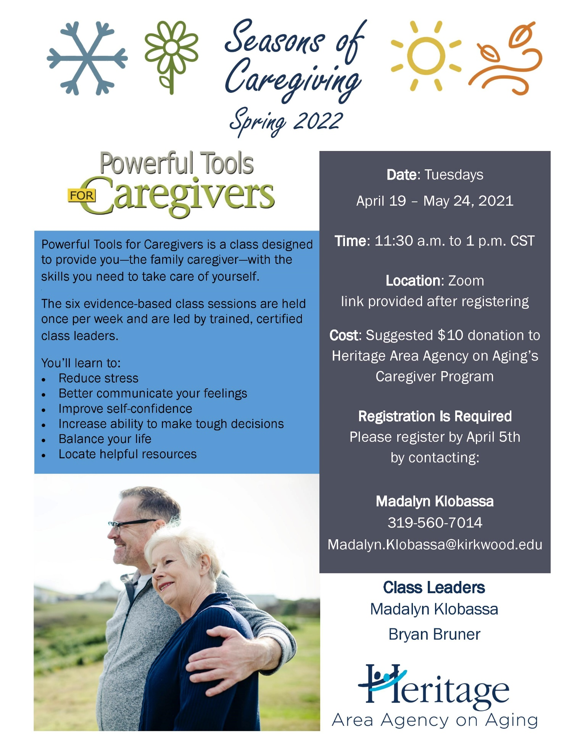

Iowa City Public Library March Events
https://www.icpl.org/events/40104/2nd-sunday-garden-forum-university-iowas-trees
2nd Sunday Garden Forum: the University of Iowa's Trees
Sunday, March 13, 2022 - 2:00pm to 4:00pm
In-person event + Livestream - Meeting Room A, Meeting Room B, Meeting Room C
Andrew Dahl, the University of Iowa Urban Forestry Supervisor and Campus Arborist, will give a visual survey and commentary on the most notable of the 8,000 trees / 320 species of trees on the UI properties. This event will be held in-person in ICPL's meeting room A and streamed live on ICPL's YouTube channel: https://youtube.com/thelibrarychannel
https://www.icpl.org/events/41790/everything-old-new-again-getting-ready-1950-us-census
Everything Old is New Again: Getting Ready for the 1950 U.S. Census release
Wednesday, March 16, 2022 - 7:00pm to 8:00pm
Zoom event + Livestream
The 1950 U.S. Census is scheduled for release April 1, 2022. Our guest speaker Laura Kovarik has been involved in genealogy for more than 25 years, she has a Master of Urban Planning which offers a solid background for exploring census records.
Registration is required for this event. You will receive a confirmation email with the zoom details after registering. This event will also be streamed live on the ICPL YouTube channel: https://youtube.com/thelibrarychannel
https://www.icpl.org/events/41099/what-heck-just-happened-processing-our-pandemic-years
What the Heck Just Happened? Processing our pandemic years
Tuesday, March 29, 2022 - 6:30pm to 8:00pm
Meeting Room A, Meeting Room B, Meeting Room C
This month marks the 2-year anniversary of the first COVID-19 shut-downs. We want to provide you with an opportunity to start processing what you've been through -- reflect on what's happened, meet with others doing the same, and share your thoughts if you like. Take some time to journal on your own, and we’ll meet in person at the library on March 29 for a community conversation facilitated by library staff. Your journaling can take any shape you like: daily reflections, long form writing, art/word art, quick associations...whatever feels right for you. Registration isn't necessary, but we encourage it so that we can arrange socially-distanced seating in the Meeting Room. Also, registrants can stop by the Info Desk to pick up a journal and pen, to get you started for the event!

Café (Clean Air For Everyone)
Café (Clean Air For Everyone) is a local coalition that has been working on tobacco related issues for almost 30 years. If you’re concerned about a child or grandchild smoking or vaping, or generally want to be involved a group that makes a difference in the community, email Susan Vileta at svileta@johnsoncountyiowa.gov to learn more and join the group.


Local Programming & News
AARP Iowa- Upcoming Events
Alzheimer's Association- Upcoming Events and Support Groups
COVID Recovery Iowa- Facebook Group Silver Linings
Hancher Auditorium- Upcoming Events
Iowa City Senior Center- March and April Program Guide
North Liberty Senior 55+ Connections Lunch- In-person lunches and programming- Click here for the calendar. Call (319) 626-5701 or email agolly@northlibertyiowa.org
Stanley Museum of Art- Click here for their website.
Solon Senior News- Click here for their March Newsletter
TRAIL of Johnson County- Their calendar features a curated collection of virtual public events (as well as those just for TRAIL members) that they select from local, regional, and national sources. That link is here: https://trailofjohnsoncounty.org/calendar
UI Center for Human Rights- Upcoming Events

*THE JOHNSON COUNTY LIVABLE COMMUNITY NEWSLETTER IS A DIGITAL NEWSLETTER- THIS HAS BEEN CONVERTED TO A PRINTABLE FORMAT FOR ALL TO READ. PLEASE NOTE THAT MANY OF THE CLICKABLE LINKS WILL ONLY WORK WHEN VIEWED THROUGH A DIGITAL DEVICE.
TO SUBSCRIBE TO THE MONTHLY JOHNSON COUNTY LIVABLE COMMUNITY NEWSLETTER YOU MAY VISIT https://livablecommunity.us3.list-manage.com/subscribe?u=a9f307a3cbce1cc4ca622bb7f&id=d21460a2e3 or contact Jeff Kellbach at 319-688-5842 or by email at jkellbach@johnsoncountyiowa.gov

